**PRACTICAL No.4**

**AIM: Write a Program to read two integer numbers and find the difference between first and second number.**

**STEPS:**

#Write a Program to read two integer numbers and find the difference between first and second number.

print("Enter two numbers to find difference")

num1=int(input("Enter first number: "))

num2=int(input("Enter second number: "))

print(num1-num2)

____________________________________________________________________________________________________________________________________________________________________________________________________________________________________________________________________________________________________________________________________________________________________________________________________________________________________________________________________________________________________________________________________________________________________________________________________________________________________________________________________________________________________________________________________________________________________________________________________________________________________________________________________________________________________________________________________________________________________________________________

**SCREENSHOT:**

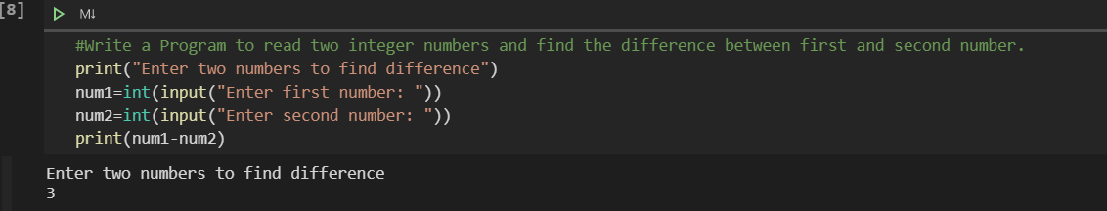

**Date:**